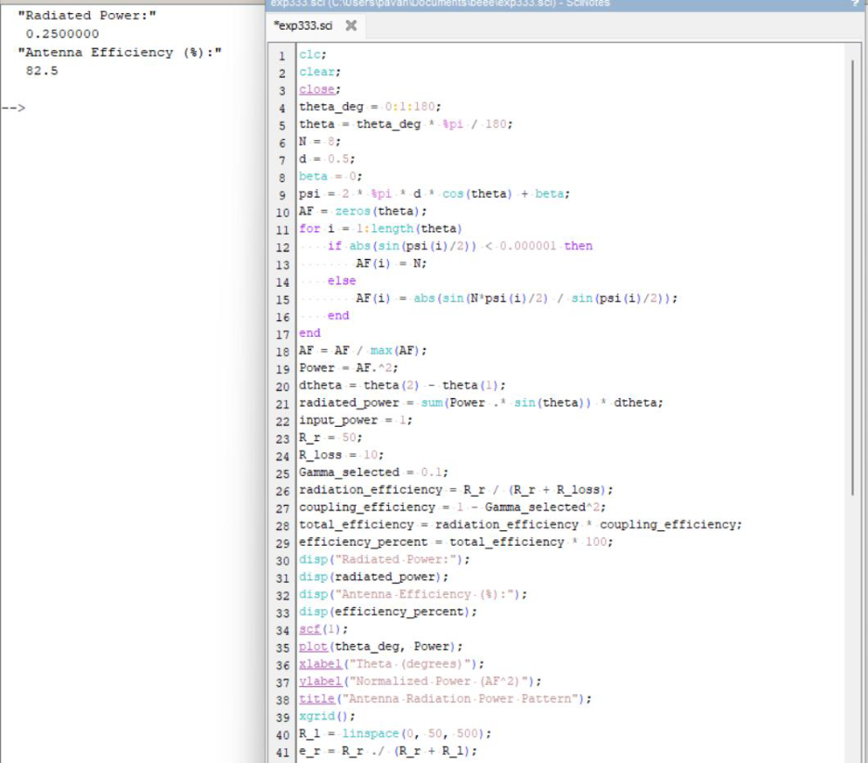

EXP 19:
Determination and plotting of Antenna Efficiency.
Aim: To determine and plot Antenna Efficiency and to Estimate the efficiency based on
radiated and input power.
INTPUT Code:

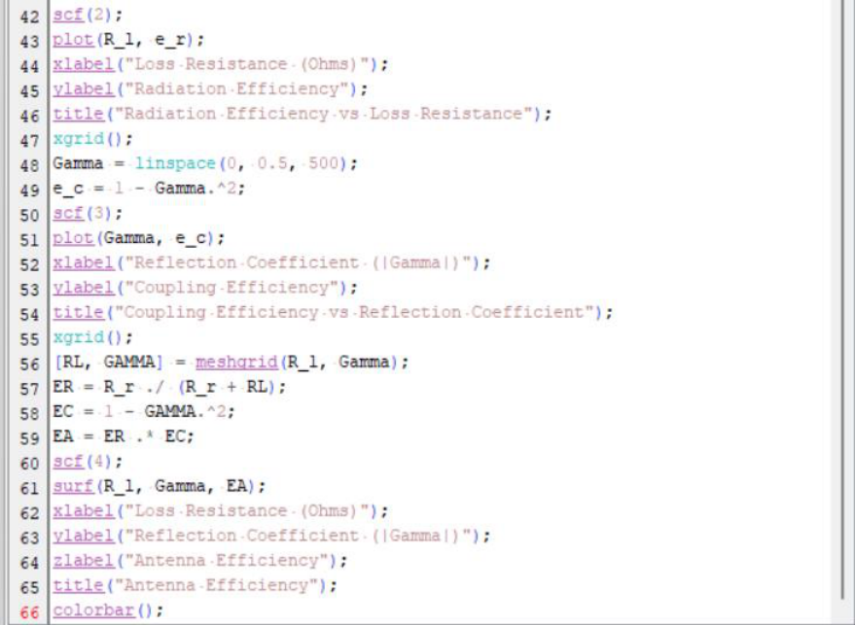
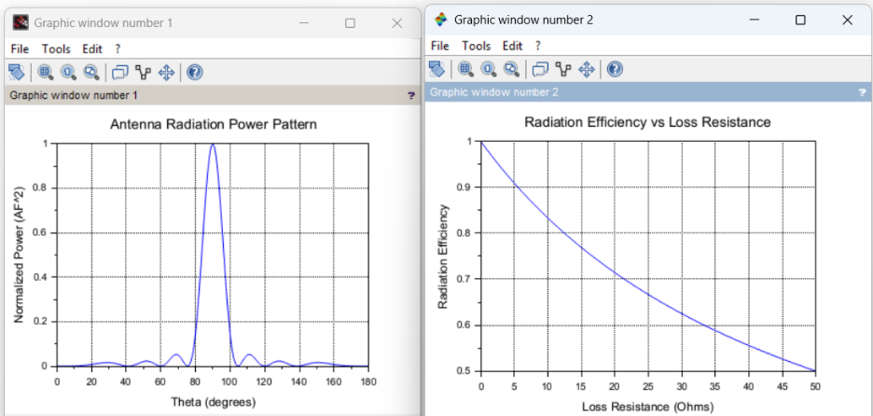

OUTPUT:

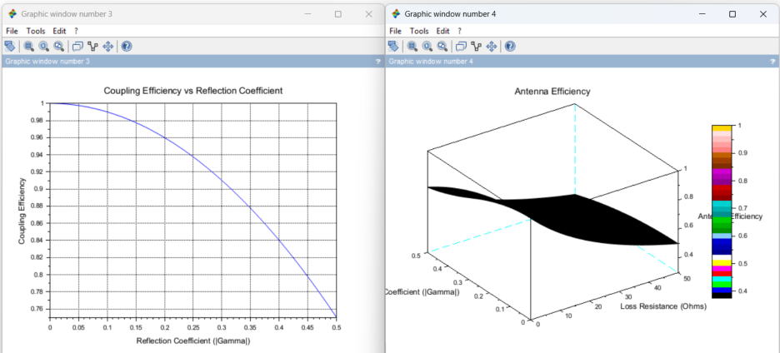
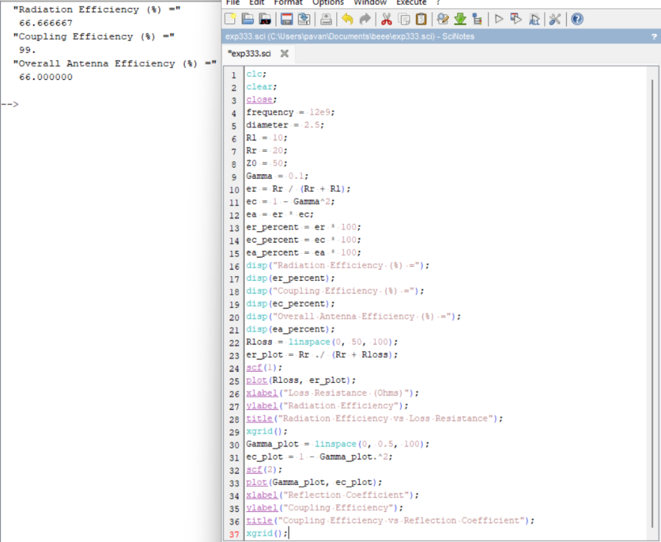

CASE STUDY 1: Antenna Efficiency in Satellite Communication Systems

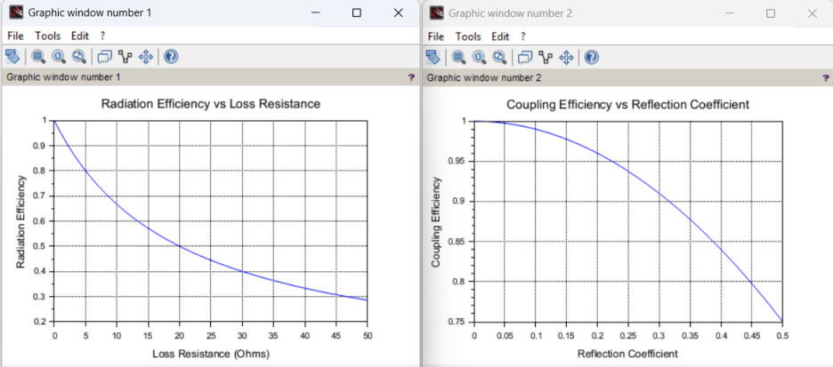
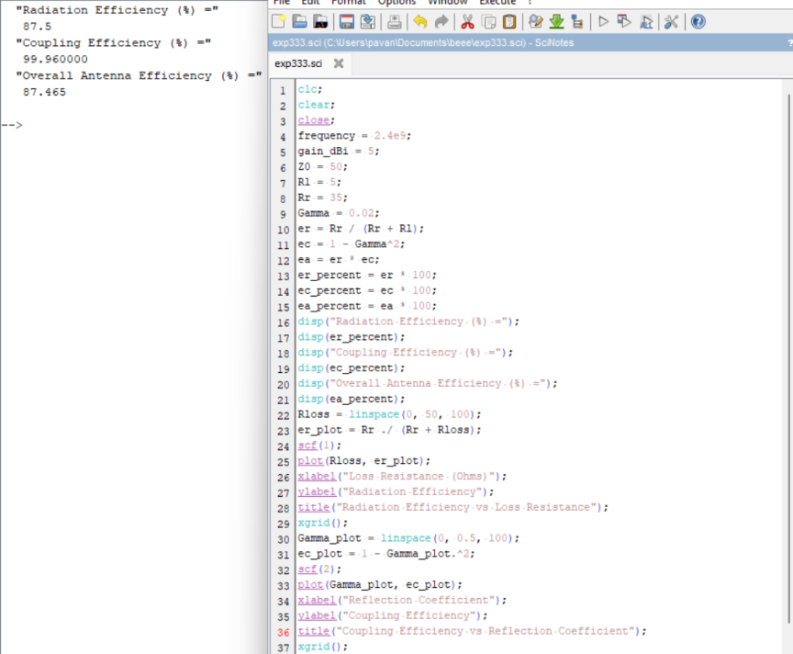

OUTPUT:
Case Study 2: Antenna Efficiency in Wireless LAN

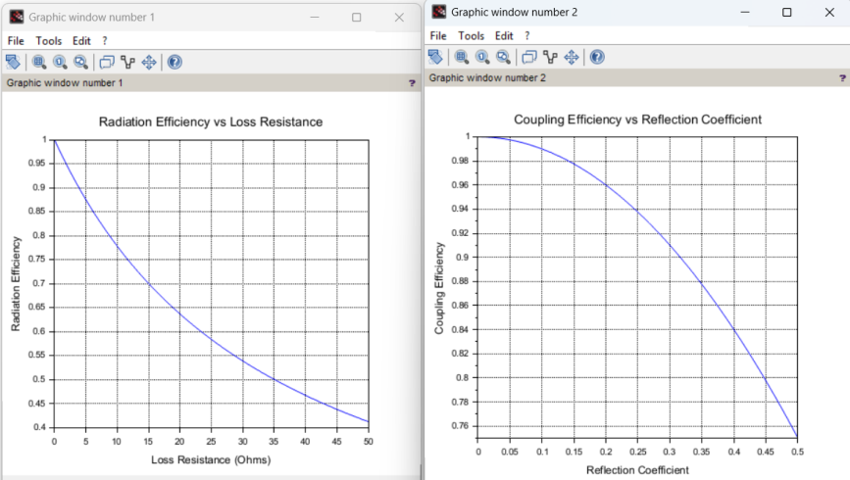
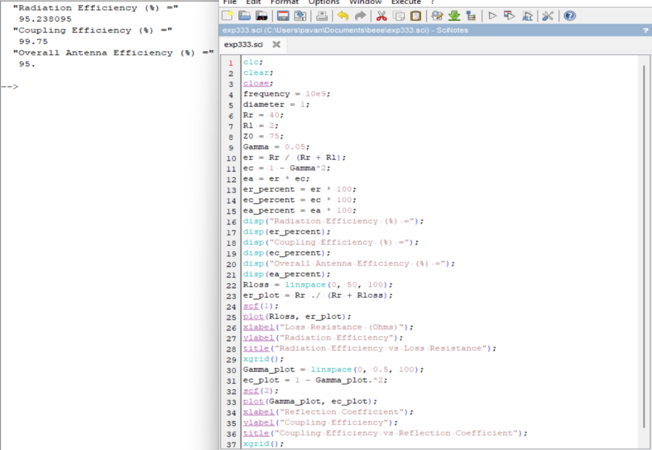

OUTPUT:
Case Study 3: Antenna Efficiency in Radar Systems

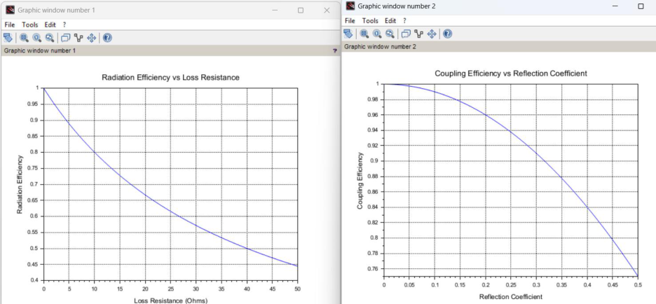
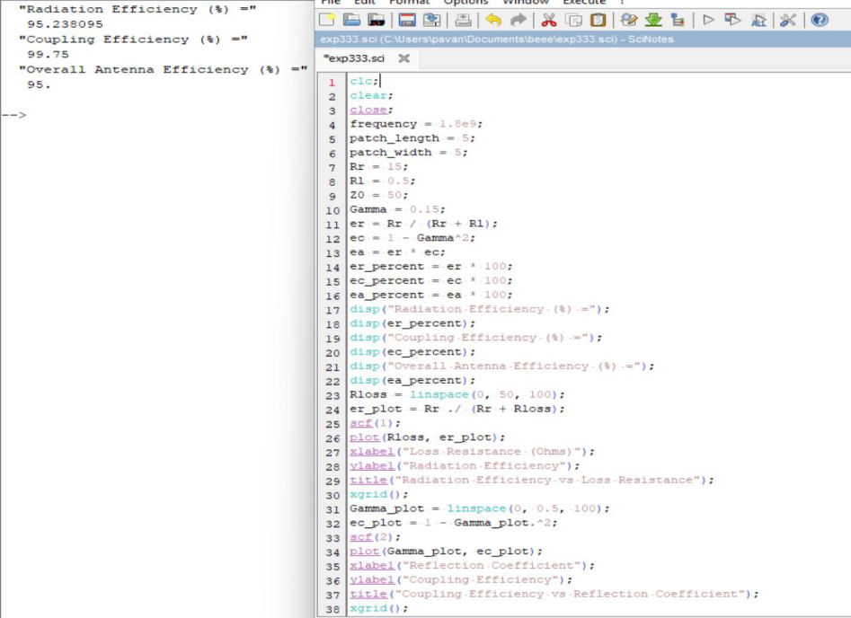

OUTPUT:
Case Study 4: Efficiency of a Microstrip Patch Antenna for Mobile Communication

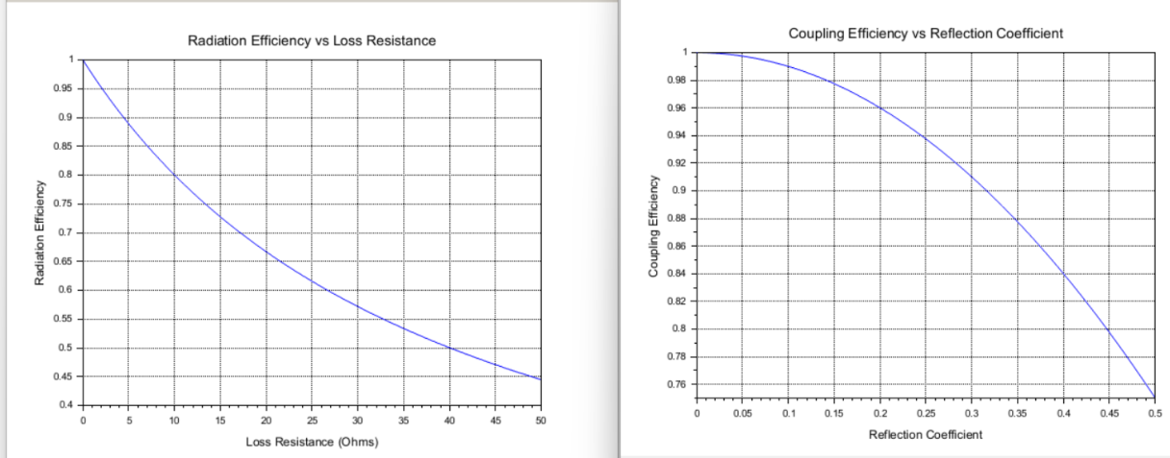

OUTPUT:

